Milestone 1 Submission
Stray Animal Rescue Tracker
Student 1 | Mehek Murtaza
Student 2 | Somna Imran
Submitted To | Ali Hassan
Subject | Database Management Systems
Semester | IV Session 2024–2028
Date | April 26, 2025

1. Version Control Table
Version | Milestone | Description | Status
v1.0 | Project Proposal | Project Proposal — problem statement, objectives, scope, and preliminary data design submitted. | Completed
v1.1 | ERD Diagram | Entity Relationship Diagram showing all table relationships, cardinality, and primary/foreign keys. | Completed

2. Entity-Relationship Diagram (ERD)
The ERD below was designed using draw.io and represents all tables of the Stray Animal Rescue Tracker along with their relationships, primary keys, foreign keys, and cardinality.

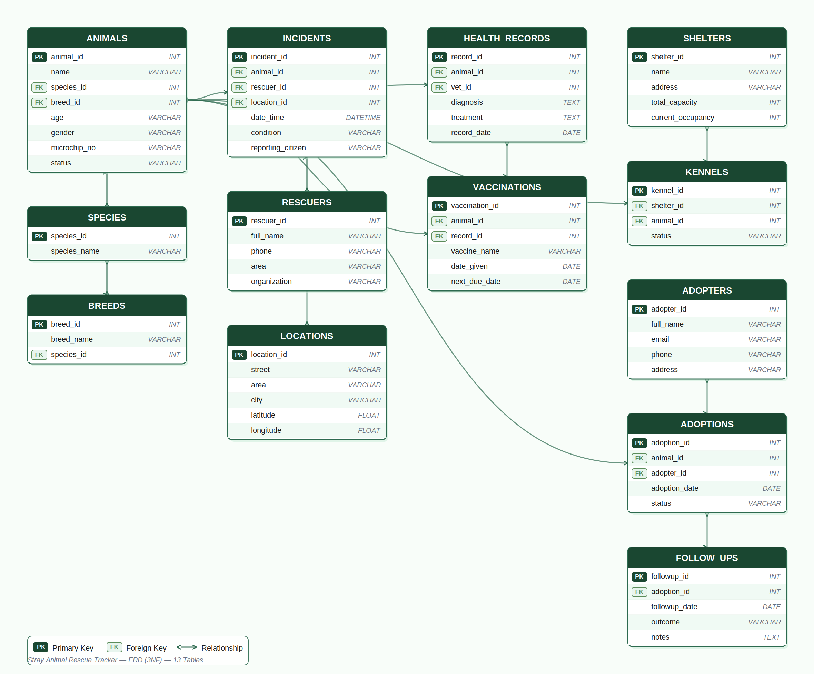

3. Relational Database Schema
The database consists of 13 normalized tables across 5 functional modules, designed to Third Normal Form (3NF). Each table is described below with its attributes, primary key, and foreign key relationships.

Table Name | Primary Key | Foreign Keys
Animals | animal_id | species_id → Species, breed_id → Breeds
Species | species_id | —
Breeds | breed_id | species_id → Species
Incidents | incident_id | animal_id → Animals, rescuer_id → Rescuers, location_id → Locations
Rescuers | rescuer_id | —
Locations | location_id | —
Health_Records | record_id | animal_id → Animals, vet_id → Vets
Vaccinations | vaccination_id | animal_id → Animals, record_id → Health_Records
Shelters | shelter_id | —
Kennels | kennel_id | shelter_id → Shelters, animal_id → Animals
Adopters | adopter_id | —
Adoptions | adoption_id | animal_id → Animals, adopter_id → Adopters
Follow_Ups | followup_id | adoption_id → Adoptions

3.1 Animals
The central table of the system. Stores the complete profile of every animal tracked, including name, age, gender, microchip number, and current status (Rescued / In Shelter / Adopted / Deceased). The animal_id is the primary key referenced by Incidents, Health_Records, Vaccinations, Kennels, and Adoptions. The microchip_no field has a UNIQUE constraint to prevent duplicate animal registrations.

3.2 Species
A catalogue of animal species (e.g., Dog, Cat, Bird). Keeps the Animals table clean and avoids free-text species entries. Referenced by both the Animals and Breeds tables.

3.3 Breeds
Stores breed information per species. Linked to Species via species_id so that breed lists are species-specific. Referenced by the Animals table for precise animal classification.

3.4 Incidents
Logs every rescue event. Captures location coordinates, date and time of rescue, animal condition on arrival, reporting citizen details, and the assigned rescuer. Each incident links to exactly one animal and one rescuer. Multiple incidents can relate to the same location (e.g., a known hotspot).

3.5 Rescuers
Stores volunteer and staff rescuer profiles including name, contact, area of operation, and organization affiliation. A rescuer can be linked to multiple incidents over time.

3.6 Locations
Stores GPS-tagged address records including street, area, city, and coordinate fields. Shared across multiple incidents to avoid address duplication and enable geographic hotspot analysis.

3.7 Health_Records
Each row represents one veterinary examination or treatment event for an animal. Records the diagnosis, prescribed treatment, attending vet, and date. One animal can have many health records over time (one-to-many). Links to a Vets reference table via vet_id.

3.8 Vaccinations
Tracks individual vaccination events linked to an animal and optionally to a health record. Stores vaccine name, date administered, and next due date. This table powers the vaccination map and outbreak early-warning system described in the project objectives.

3.9 Shelters
Stores shelter facility profiles including name, address, total capacity, and contact information. Referenced by the Kennels table to track per-shelter occupancy. The system triggers capacity alerts when a shelter’s occupancy reaches 80%.

3.10 Kennels
Represents individual kennel units within a shelter. Each kennel row records which animal currently occupies it, its status (Available / Occupied / Under Maintenance), and the shelter it belongs to. Enables fine-grained capacity tracking beyond simple headcounts.

3.11 Adopters
Stores adopter profiles including full name, contact details, address, and ID verification status. An adopter can adopt multiple animals over time. The email field has a UNIQUE constraint to prevent duplicate adopter accounts.

3.12 Adoptions
Records confirmed animal-to-adopter pairings. Stores adoption date, terms agreed upon, and current status (Active / Returned / Closed). A composite UNIQUE constraint on (animal_id) ensures each animal can only have one active adoption at a time.

3.13 Follow_Ups
Logs post-adoption welfare check-ins. Each follow-up is linked to an adoption record and stores the date, outcome (Good / Concern Raised / No Response), and follow-up notes. Multiple follow-ups can belong to one adoption.

4. Key Relationships
Animal ↔ Species / Breed (Many-to-One)
Each animal belongs to exactly one species and one breed. Species and Breeds are independent lookup tables, and Breeds is further scoped to its species, preventing cross-species breed assignments.
Animal ↔ Incidents (One-to-Many)
An animal can be involved in multiple rescue incidents (e.g., a re-stray after failed adoption). Each incident belongs to exactly one animal and one rescuer.
Animal ↔ Health_Records (One-to-Many)
Each animal accumulates health records over time. Every medical examination, treatment, or diagnosis is stored as a separate record linked to the animal.
Shelter ↔ Kennels (One-to-Many)
One shelter contains many kennels. This relationship enables real-time occupancy tracking at the kennel level and rolls up to shelter-level capacity dashboards.
Adopter ↔ Adoptions → Follow_Ups (One-to-Many → One-to-Many)
An adopter can adopt multiple animals. Each adoption generates multiple follow-up checks. This chain ensures post-adoption welfare is continuously tracked and documented.
Location ↔ Incidents (One-to-Many)
A single location (GPS-tagged area) can be linked to multiple rescue incidents. This drives the geographic hotspot mapping and stray density analysis features of the system.

5. Data Integrity Constraints
- Primary Keys: Every table uses an AUTO_INCREMENT integer primary key ensuring uniqueness across all records.
- Foreign Keys: All inter-table references are enforced with FOREIGN KEY constraints to maintain referential integrity and prevent orphan records.
- NOT NULL: Core fields such as animal names, incident dates, and contact information cannot be left empty.
- UNIQUE: The microchip_no field in Animals prevents duplicate animal entries. The email fields in Rescuers and Adopters prevent duplicate accounts. A composite UNIQUE constraint on (animal_id) in Adoptions prevents double-adoption of a single animal.
- CHECK Constraints: Animal status is restricted to valid lifecycle values (Rescued, In Shelter, Adopted, Deceased). Kennel status is constrained to Available, Occupied, or Under Maintenance. Adoption status is constrained to Active, Returned, or Closed.
- Normalization: The schema is fully normalized to 3NF — no repeating groups, no partial dependencies, and no transitive dependencies across all 13 tables.
- Triggers: An on_rescue_insert() trigger auto-creates a blank health record upon every new incident entry, ensuring no animal enters the system without a medical tracking record.
- Stored Procedures: The auto_assign_shelter() procedure automatically assigns a rescued animal to the nearest shelter with available kennel capacity.

